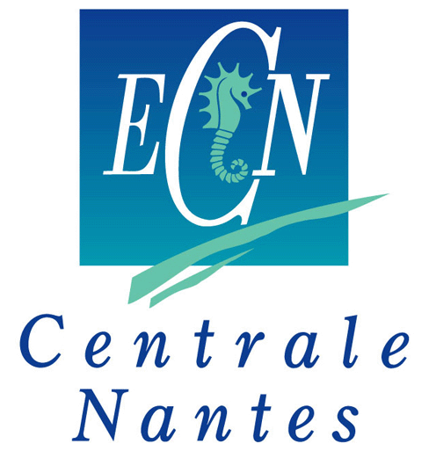
南特中央理工大学中法合作项目申请表格
Ecole de Centrale Nantes
Application form for Sino-French Joint program
（to fill in English unless otherwise stated）
申请项目Program
3+1+2本硕连读项目 Master硕士

就读院校Home University

姓名Name in Chinese： 性别Gender： 男Male 女female

Name in English(与护照一致)：

ID card number（身份证号）

出生日期Date of Birth：

联系电话Mobile phone：

邮箱Email:

年级Current Grade: 大三Benke 3 大四 Benke 4 研一 M1

就读学院College or School

所读专业Specialty

专业平均成绩Average Score

英语水平English level 雅思IELTS 或托福TOEFL
如未考试，计划何时考？If no score, when you will take the test?

申请专业Specialty
Masters of Engineering in Applied Mechanics:
Hydrodynamics and Ocean Engineering Energetics and propulsion
Computational Mechanics Design of Systems and Products
Materials Process and Technology of Composites
Master s of Civil Engineering:
Civil Engineering
Masters of Engineering in Automatic Control, Robotics and Applied Informatics:
Automatic Control, Signal, & Image Advanced Robotics
Real Time, Steering and Supervision
Masters of Engineering in Urban Environment
Urban Environment
Master A.M.A.S.O.N.E
Ship operation and Naval engineering

动机Motivation:

