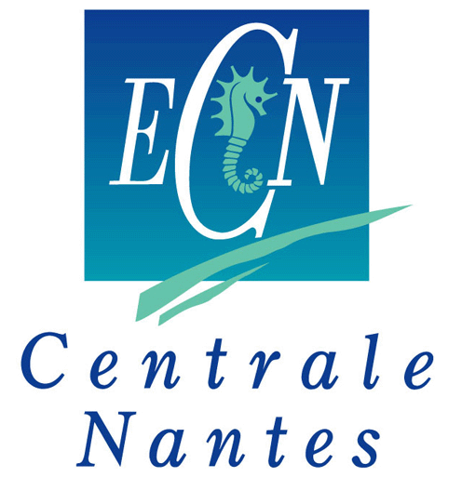
南特中央理工大学中法合作项目申请表格
Ecole de Centrale Nantes
Application form for Sino-French Joint program
（to fill in English unless otherwise stated）
申请项目Program
3+1+2本硕连读项目 Master硕士

就读院校Home University

姓名Name in Chinese： 性别Gender： 男Male 女female

Name in English(与护照一致)：

ID card number（身份证号）

出生日期Date of Birth：

联系电话Mobile phone：

邮箱Email:

年级Current Grade: 大三Benke 3 大四 Benke 4 研一 M1

就读学院College or School

所读专业Specialty

专业平均成绩Average Score

英语水平English level 雅思IELTS 或托福TOEFL
如未考试，计划何时考？If no score, when you will take the test?

申请专业Specialty
Marine Technology (M-TECH)
Hydrodynamics for Ocean Engineering (M-TECH HOE)
Atlantic Master on Ship Operation & Naval Engineering (M-TECH AMASONE)
Mechanical Engineering (M-ENG)
Advanced Manufacturing (M-ENG AM) formerly Design of Systems and Products
Computational Mechanics (M-ENG CM)
Energetics and Propulsion - (M-ENG EP)
Materials, Processes and Technology of Composites (M-ENG MPTC)
Control and Robotics (CORO)
Signal and Image Processing (CORO SIP)
Advanced Robotics (CORO IMARO)
Embedded Real Time Systems (CORO ERTS)
Control Systems (CORO CSYS)
Supervision - Production Management (CORO SPM)
Civil Engineering (C-ENG)
Materials and Structures in their Environment (C-ENG MSE)
City and Urban Environments (U-ENV)
Atmosphere, Water and Urban Environment (U-ENV AWE)
Ambiances, Architecture, Urbanity (U-ENV AAU)
Industrial Engineering (I-ENG)
Agile Factory Management (I-ENG AFM)
Smart and Connected Enterprise (I-ENG SCE)

动机Motivation:

